Press release 125AM23
Application Maag, Grossostheim March 2023
Workpiece clamping technology from AMF supports highly efficient production of precision components for plastic manufacturing
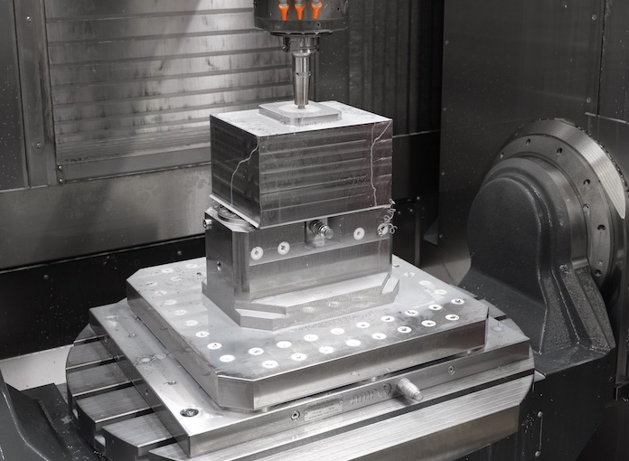
Efficiency achieved in set-up across all processes
Press contact:
ANDREAS MAIER GmbH & Co. KG
Marcel Häge
Waiblinger Strasse 116
D-70734 Fellbach
Tel. +49 (0)711 – 57 66 - 264
haege{at}amf.de
www.amf.de
Maag Germany GmbH
Ostring 19
D-63762 Grossostheim
Annika Bellof, Marketing Manager
T +49 6026 503 296
annika.belloff{at}maag.com
www. Maag.com

(Fellbach/Grossostheim) The good quality of plastic products depends on how pure the plastics melt is and how exact the volume of granulate is. Accordingly, the granulate and filter systems as well as the screen changers have an overriding importance. They must be precisely made, run without interruption as much as possible and reliably filter out foreign matter and dirt particles. As a manufacturer with great competence and production depth, MAAG in Grossostheim has relied in its production on modular workpiece clamping technology from AMF for more than ten years. Zero-point clamping systems, among others, help keep machine running times and productivity high.
“With our young team, we have made production much more efficient through numerous investments in the last five years. The modular workpiece clamping technology from AMF with the zero-point clamping systems at the centre contributes considerably to drastically reducing set-up times across all processes,” reports operations manager Ali C. Bal of Maag Germany GmbH in Grossostheim. The German factory of the Swiss MAAG Group makes high-precision components and capable machines that are essential for granulate and polymer production. The purity of the melt in the production process is just as important a requirement for the high quality of the final product as the uniform grain size of the granulate. Here, the granulate and filter system in general and the screen changers in particular play an overriding role. That the high-precision production of these components can keep pace with the growth of this MAAG area is due to investments. The comprehensive AMF workpiece clamping technology in strong and flat zero-point clamping modules makes an important contribution to low set-up times.

Modularity creates flexibility
“When the investment offensive started, we didn’t have to start from scratch, since at MAAG they have been familiar with our clamping technology for over ten years,” reports Peter Unseld, the AMF sales engineer serving MAAG. MAAG screen changers are known and proven due to the double-piston construction, which in all sizes and designs doesn’t require additional seals. As a result, these CSC screen changers work very robustly, reliably, and without leaks and maintenance. Of course, this requires highly precise machining of the stainless steel materials. For example, the gap between the cylindrical deep-hole drill holes and the pistons are only a few hundredths of a millimetre.
The screen changer housings are milled, drilled, ground, turned and honed on a total of ten 3-, 4- and 5-axis machining centres as well as several turn-milling centres. Clamping solutions from AMF are installed everywhere to ensure that the changeover between processes and machines takes place quickly and reliably without large set-up times. The trick here is modularity. Clamping plates with breadboard for pinning, hydraulic KH10- and KH20 zero-point clamping modules, block-clamping systems, collets and many components from the modular construction kit of clamping and fixture systems from AMF provide the great flexibility that operations manager Bal desires. Added to this are several clamping pillars equipped with 30 KH20 modules that likewise can be set up on base plates equipped with zero-point clamping modules. As a result, clamping can take place horizontally.

Flat and easy-to-combine plug-and-play
“Despite all flexibility, what’s important for us is that build-up doesn’t get too high and that the workpieces, some of which are quite large, can be processed without danger of collision using the machines that have a collision circle between 600 and 1500 mm,” Ali notes. Manuel Nau, sales manager at AMF, can reassure him: “That is exactly the advantage of our installation modules, base and mounting plates. Although they can apply great force, they don’t build up very high. That permits many possible combinations and ultimately the great flexibility and speed that cutters desire. That’s like plug-and-play.”
The hydraulic screw-in modules KH10 and KH20 can pull in workpieces with up to 20 kN of pull-in force and hold them in place with up to 55 kN of holding force. And so they are also suitable for direct clamping of workpieces. If a clamping plate or workpiece is pulled in, the pressure line can be decoupled as spring force mechanically locks it. Optionally, the modules have a pneumatic blow-out as well as a support control with indexing. Covers and pistons are hardened and so promise durable and wear-free use.

Holding forces and repetition accuracy make precision possible
Repetition accuracy of the clamping operations is less than 0.005 millimetres. “The large holding forces and repetition accuracy are especially important for the precision of the deep-hole drill holes. For with diameters of 150-300 mm, these screen changer cylinders must achieve the smallest tolerances,” says Bal. Precision is equally important for production of the perforated plates for the granulate systems. For only the same grain size of the pellets can ensure the grade and quality of the pellets and so that of the plastic product to be made.
Precise production of the screen changers is also especially important as the double-piston construction offers higher screen performance with smaller dimensions. It ensures continuous filtering of the polymer melt and interruption-free operation. When the screen change takes place on a piston, the production does not have to be interrupted, since the second piston continues to work. Thanks to bent screens, the filter surface of the C-series is up to four times larger than that of the classic series. The screen life accordingly increases by many times and the pressure use falls. Also, the filters can require less space with the same performance and, as a result, can be much smaller. As a result, MAAG has reached new target groups and applications, which have increased demand.

AMF with application experience for process optimisation
The program for increasing efficiency and productivity in production triggered this development. Bal summarises: “The total of the results from new machines as well as the modular clamping technology from AMF, together with the competent advice and experience of the application consultants, have increased our output considerably in the last few years.” Manuel Nau and Peter Unseld from AMF are happy to hear this. “Beyond the clamping technology products, we’re happy to use our considerable experience for process optimisation of applications.”
871 words, 6,721 characters
If printed, please send a copy to SUXES

((AMF company information))

Market leader in machine-table clamping
Today, Andreas Maier Fellbach (AMF), originally founded in 1890, is a one-stop supplier in clamping technology and one of the world market leaders. With a global market presence, the company and its employees always have an open ear for the problems of their customers. By listening to these needs, and through its strong problem-solving ability, professional consultancy, intelligent engineering and high manufacturing quality, AMF repeatedly develops project fabrications and customised solutions for customers as well as standard solutions that succeed in the market. With more than 5,000 products and numerous patents, it ranks among the top innovators in the industry. Speed, flexibility and 240 well-qualified employees guarantee success at Andreas Maier GmbH & Co. KG. In 2022, AMF earned revenue of almost 50 million euro.

((Company information, MAAG Group))

Premium supplier for the plastics processing industry
The MAAG Group is a premium supplier for the plastic processing industry. It comprises successful and renowned companies, each with an impressive history. AMN DPI, Automatik Plastics Machinery, Ettlinger Kunststoffmaschinen, Maag Pump Systems, Gala Industries, Reduction Engineering Scheer, WITTE Pump & Technology and Xantec Steueurungs- und EDV-Technik are today the capable and innovative product brands of the MAAG Group. Each one is a solution provider for customer-specific, adaptable systems and integrated solutions in the process technology for the polymer, chemical, petrochemical, pharmaceutical and food industry.

Image directory, zero-point clamping technology advisor
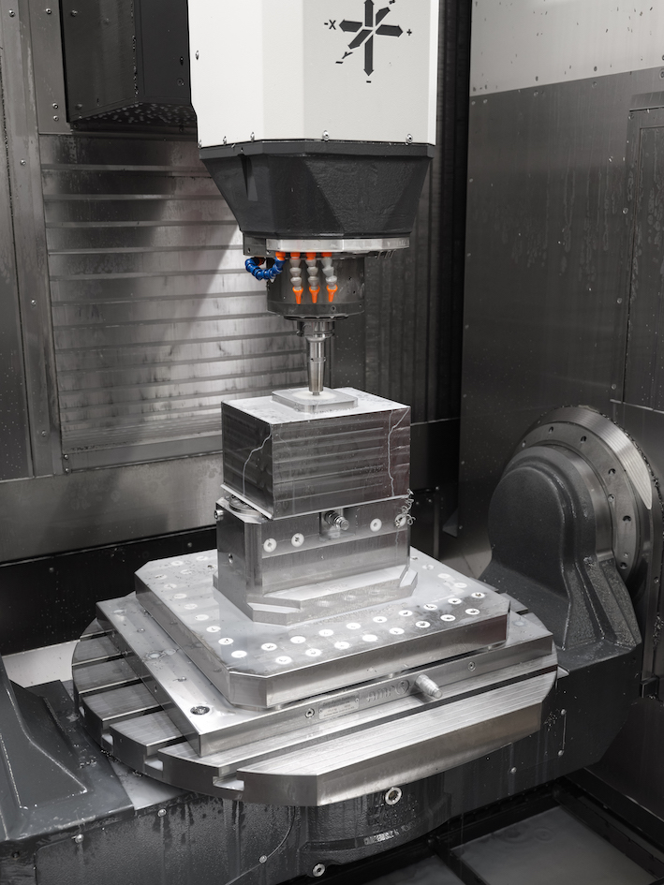
Image no. 125-00 AM_MG-Titelbild.jpg.
As a manufacturer with great competence and production depth, MAAG has relied on modular workpiece clamping technology from AMF for more than ten years.
©Image source: AMF
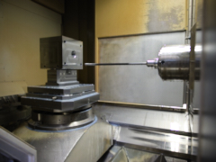
Image no. 125-01 AM_MG-Tieflochbohren.jpg.
The large holding forces and repetition accuracy of the AMF zero-point clamping modules are especially important for the precision of the deep-hole drill holes.
©Image source: AMF
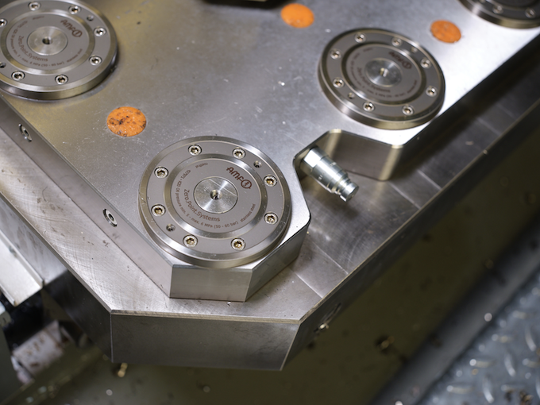
Image no. 125-02 AM_MG-Nullpunktspannsystem-Grundplatte.jpg.
The comprehensive AMF workpiece clamping technology in strong and flat zero-point clamping modules makes an important contribution to low set-up times.
©Image source: AMF
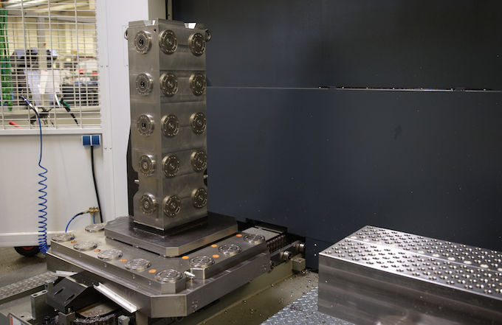
Image no. 125-03 AM_MG-Spannturm.jpg.
Horizontal clamping is also possible with clamping pillars equipped with 30 KH20 modules, which likewise can be flexibly set up on base plates equipped with zero-point clamping modules.
©Image source: AMF
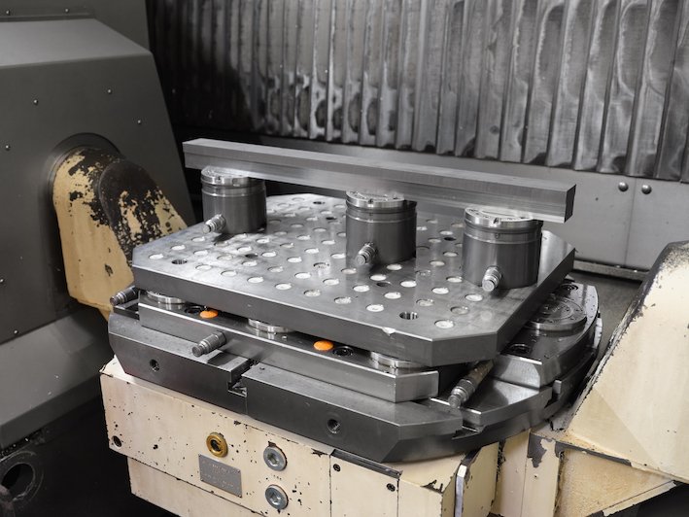
Image no. 125-04 AM_MG-Aufbau.jpg.
Although AMF zero-point clamping modules can apply great force, they don’t build up very high.
©Image source: AMF
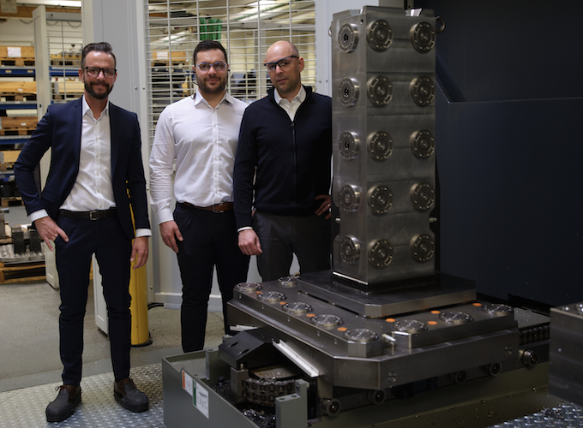
Image no. 125-05 AM_MG-People.jpg.
Ali C. Bal (middle): “The total of the results from new machines as well as the modular clamping technology from AMF, together with the competent advice and experience of the application consultants, have increased our output considerably in the last few years.”
Manuel Nau (left) and Peter Unseld (right) from AMF are happy to hear this. “Beyond the clamping technology products, we’re happy to use our considerable experience for process optimisation of applications.”
©Image source: AMF
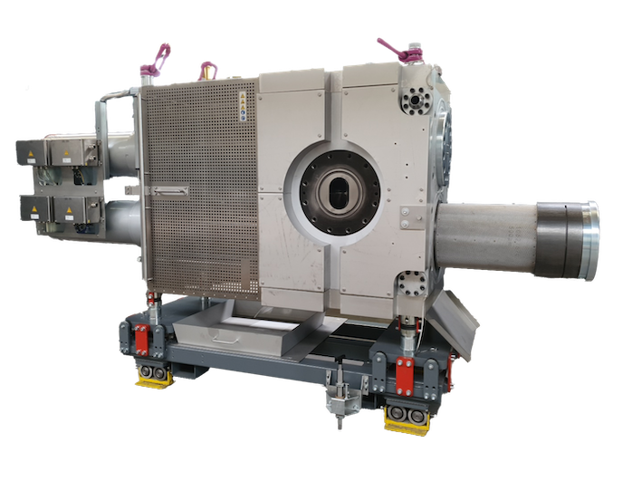
Image no. 125-06 AM_MG-CSC-Siebwechsler.jpg.
The double-piston technology in the CSC screen changers from MAAG permit interruption-free operation. Thanks to bent screens, the filter surface of the C-series is up to four times larger than that of the classic series.
©Image source: MAAG
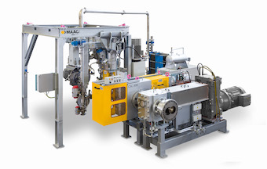
Image no. 125-07 AM_MG-CSC-UWG.jpg.
MAAG complete system comprising melt pump, screen changer and underwater granulation. The perforated plate is the core of the granulator and produced with the greatest precision.
©Image source: MAAG

